**Model Experimentation**

ML Flow UI

All the experiments (Lead_scoring_model_expermentation)

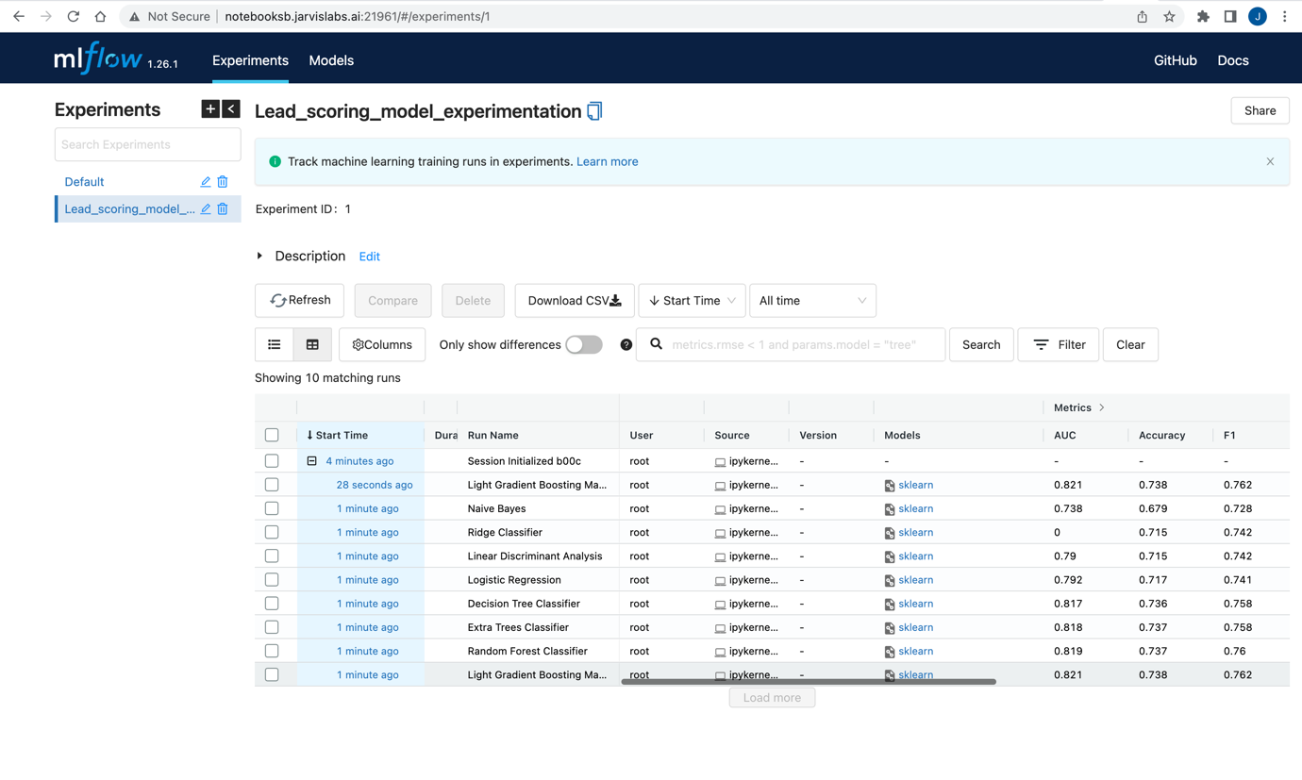

Light Gradient Boosting Machine Details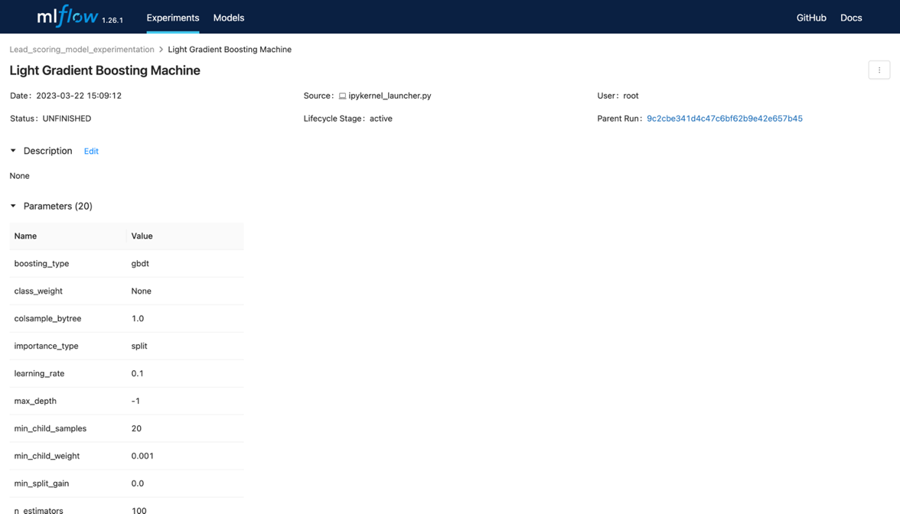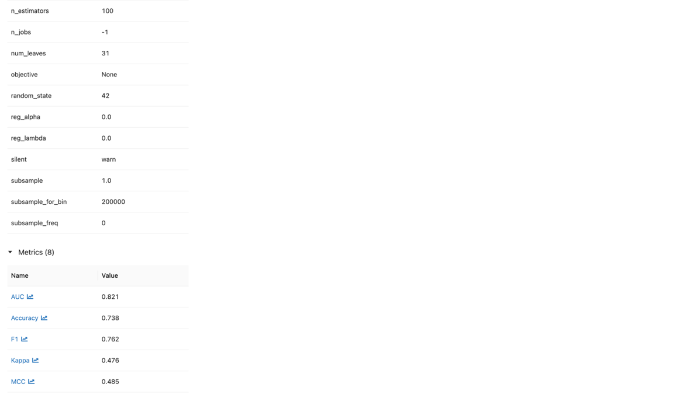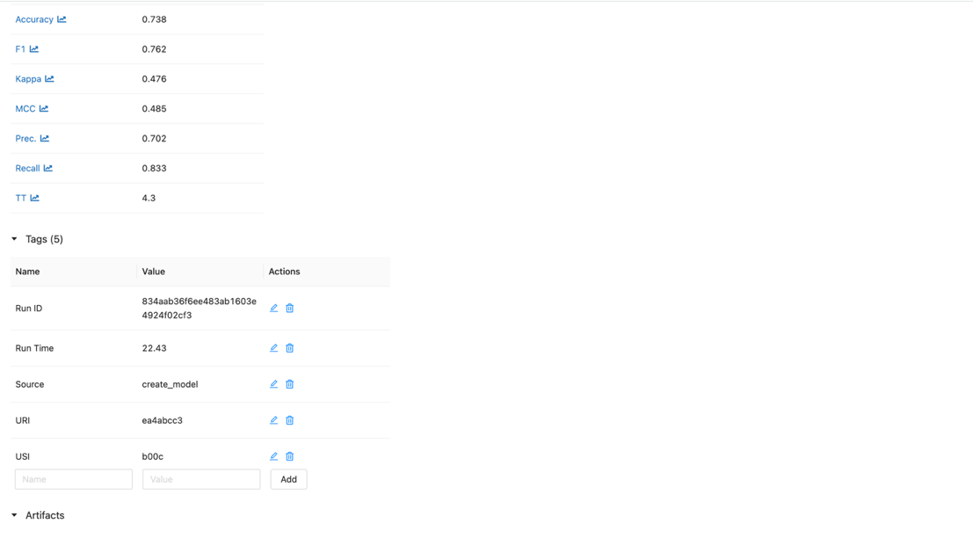

ML Flow UI after dropping features

All the experiments (Lead_scoring_model_expermentation_optimize)

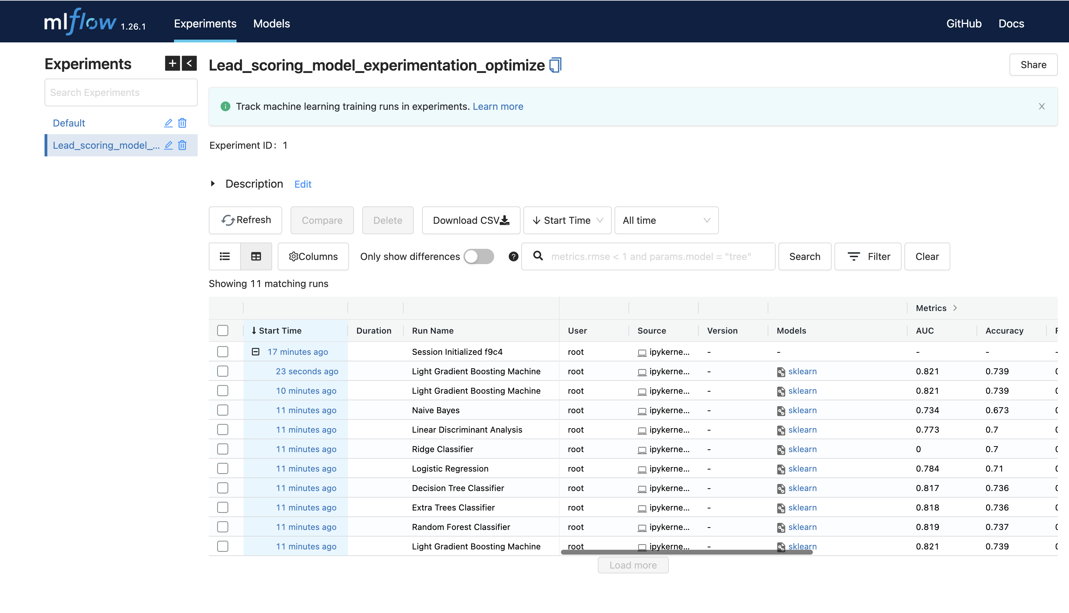

Light Gradient boosting machine (optimized)

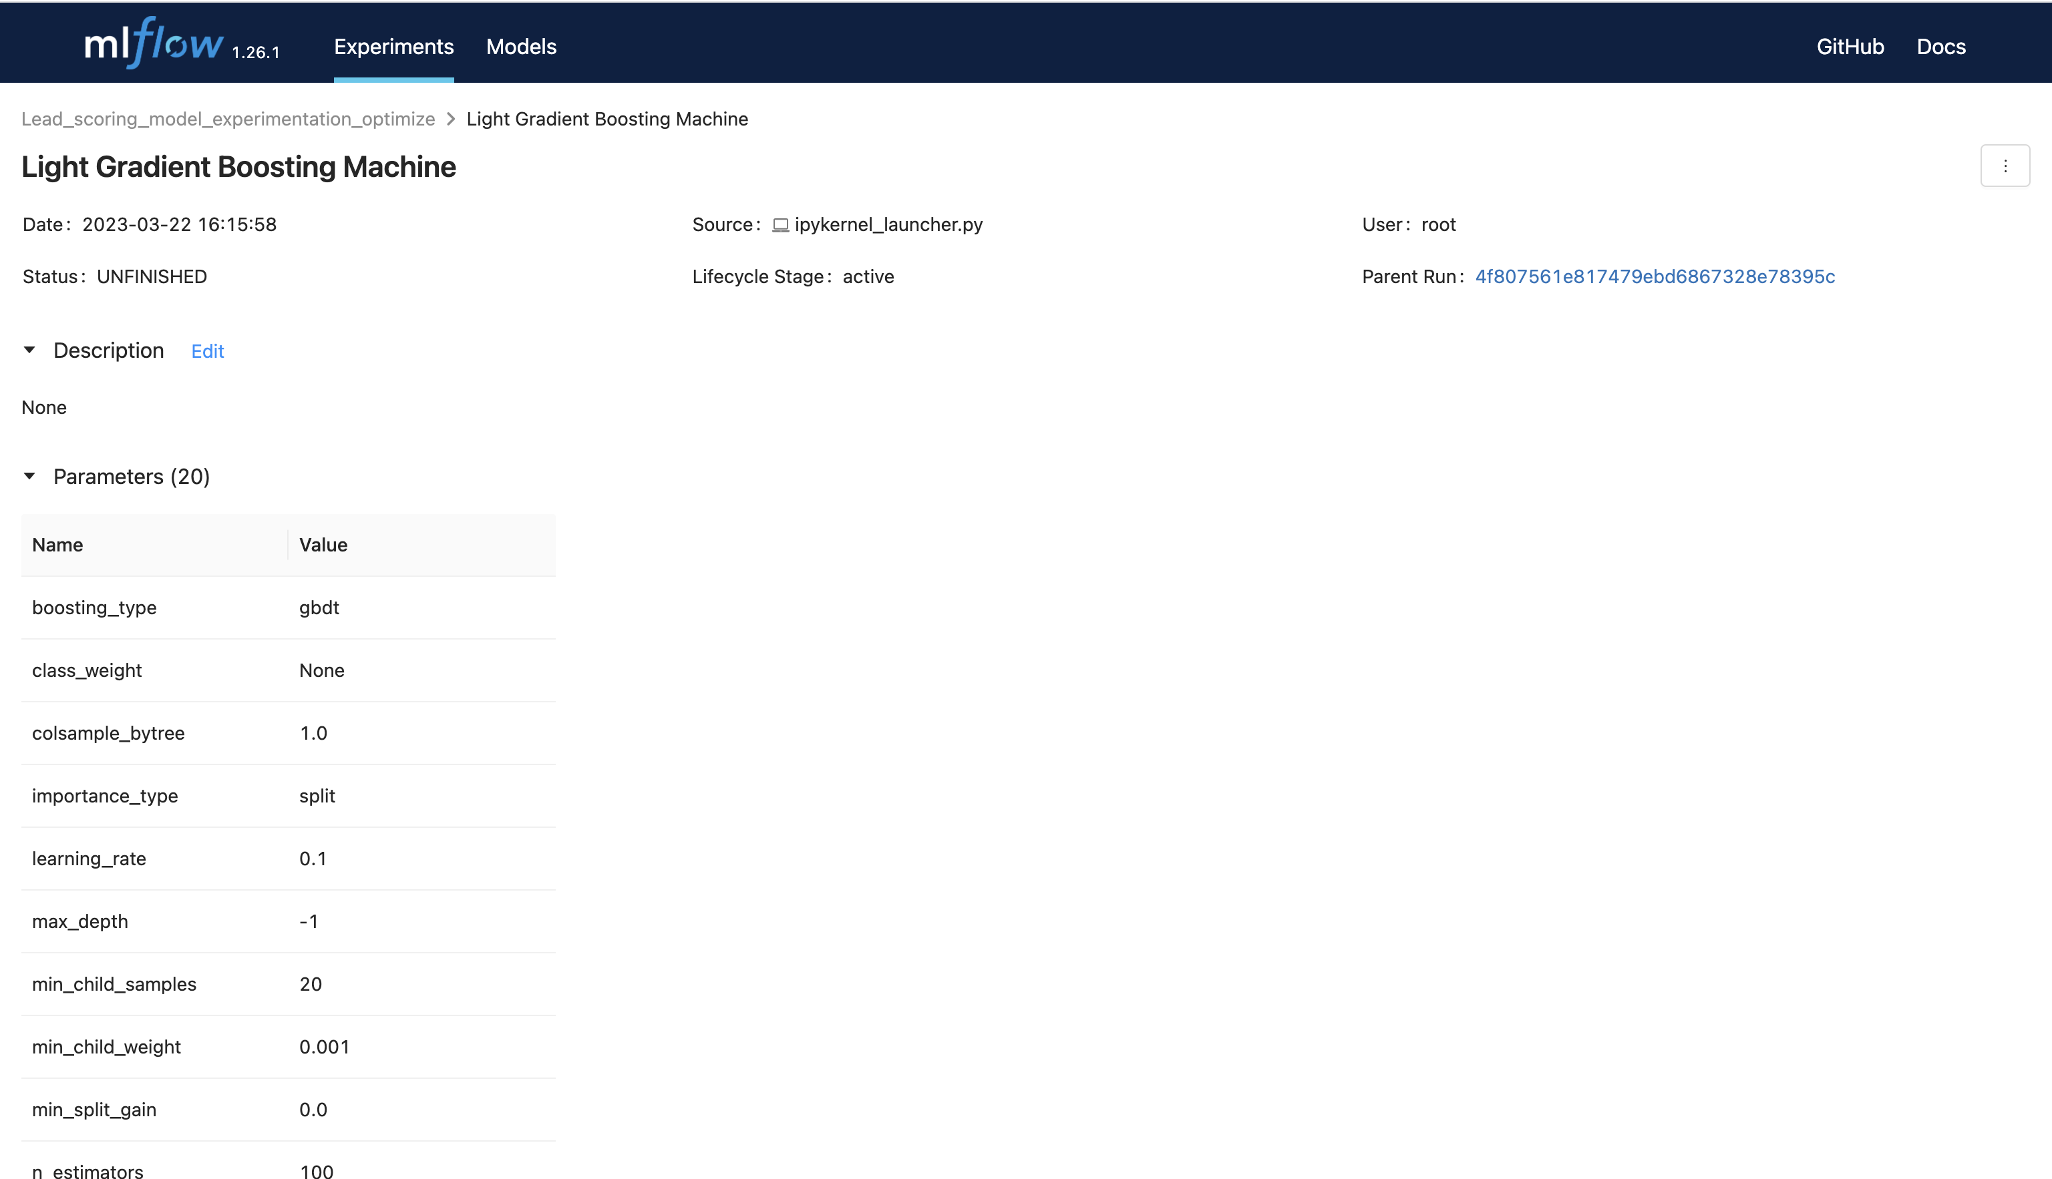

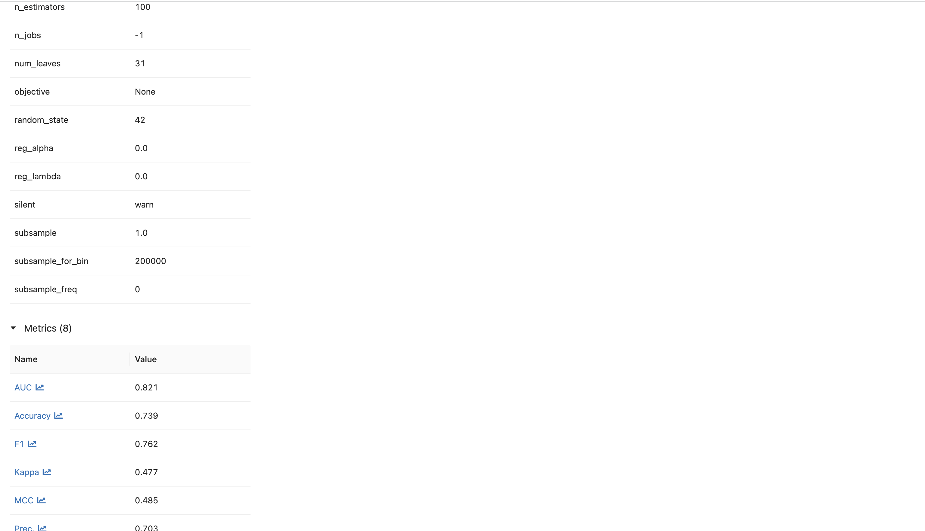

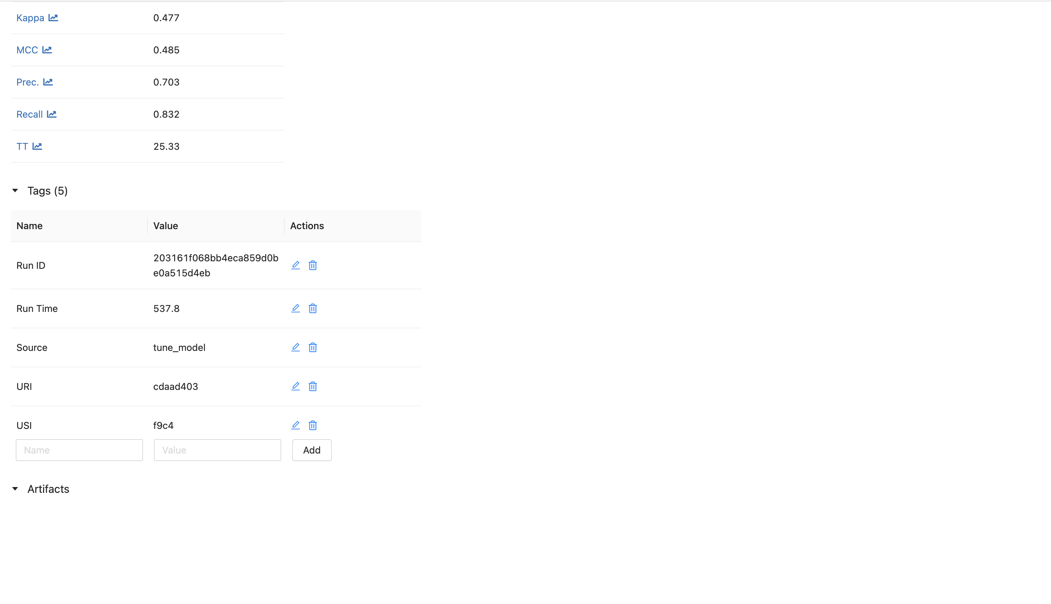

**Data Pipeline**

Air Flow UI

Airflow DAG Grid (Lead_Scoring_Data_Engineering_Pipeline)

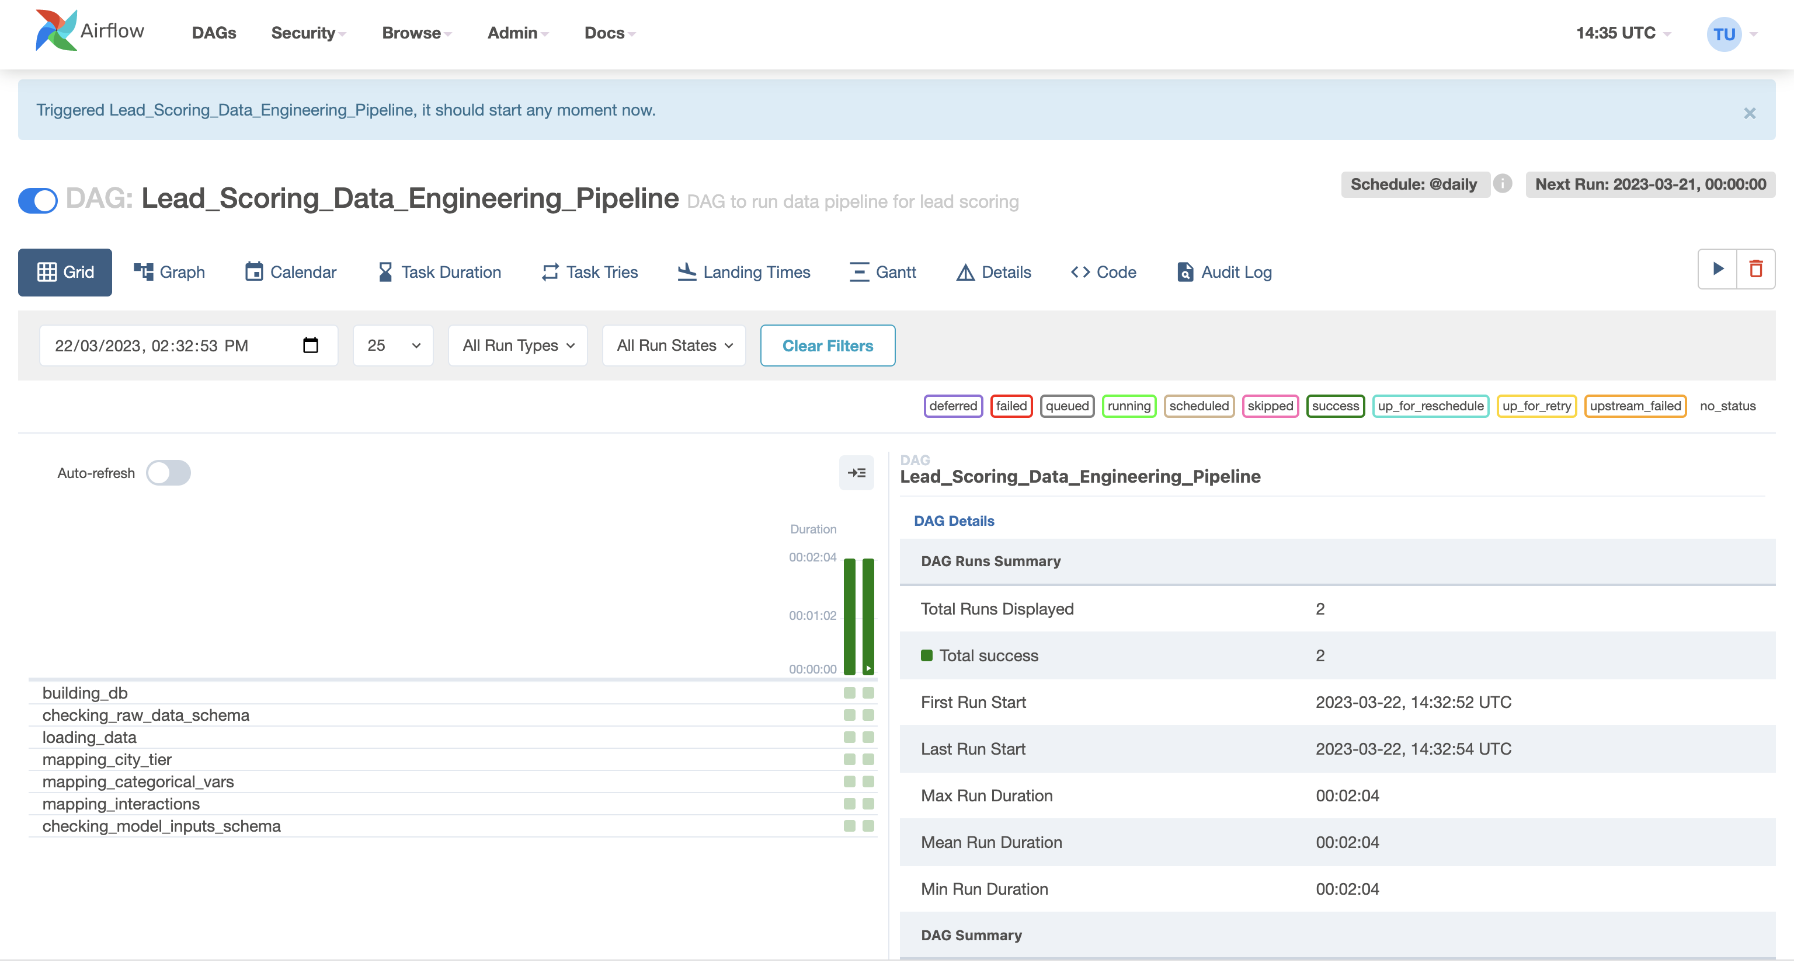

Airflow DAG Graph (Lead_Scoring_Data_Engineering_Pipeline)

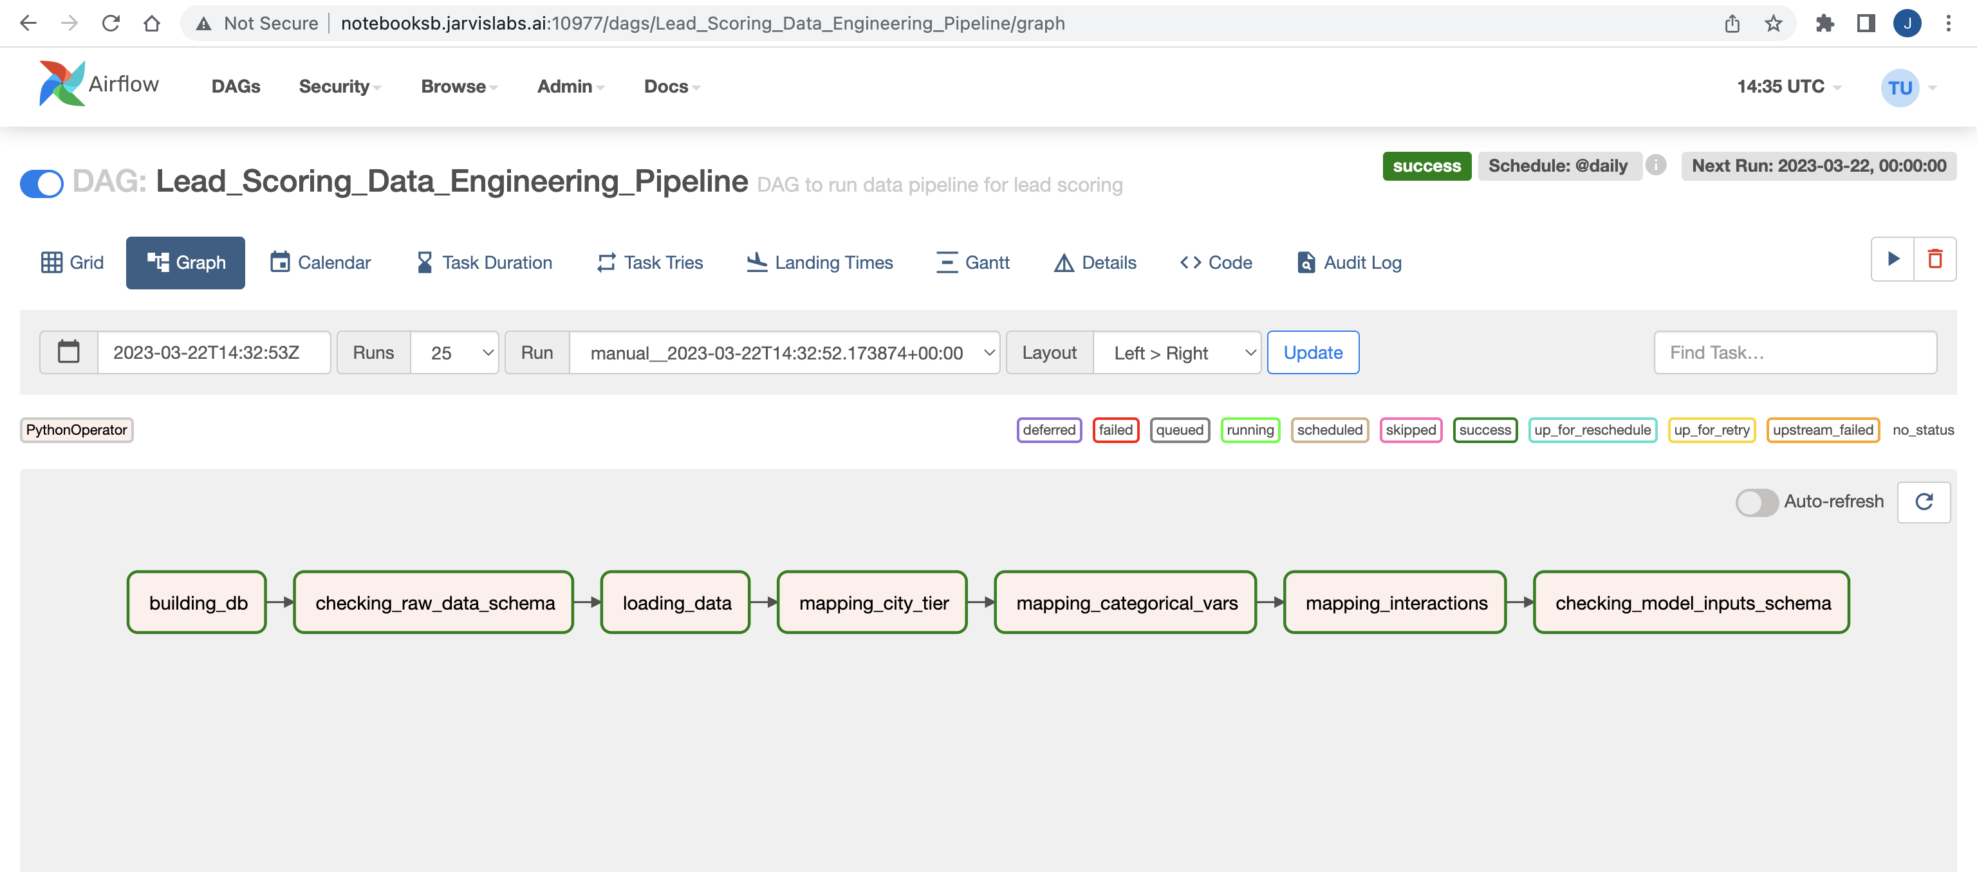

List of AirFlow DAGs

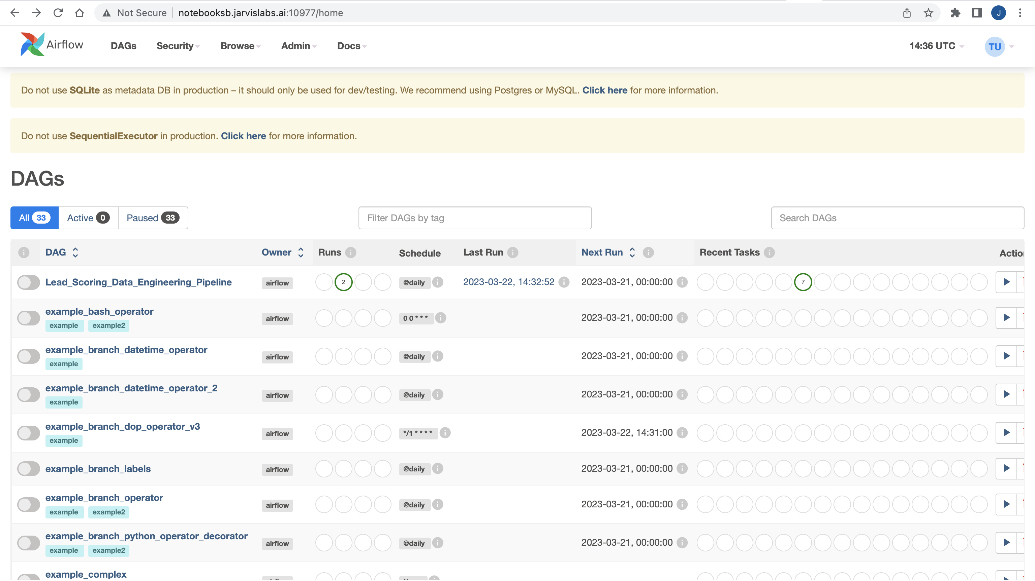

**Training Pipeline**

ML Flow UI

List of experiments (Lead_scoring_mlflow_production)

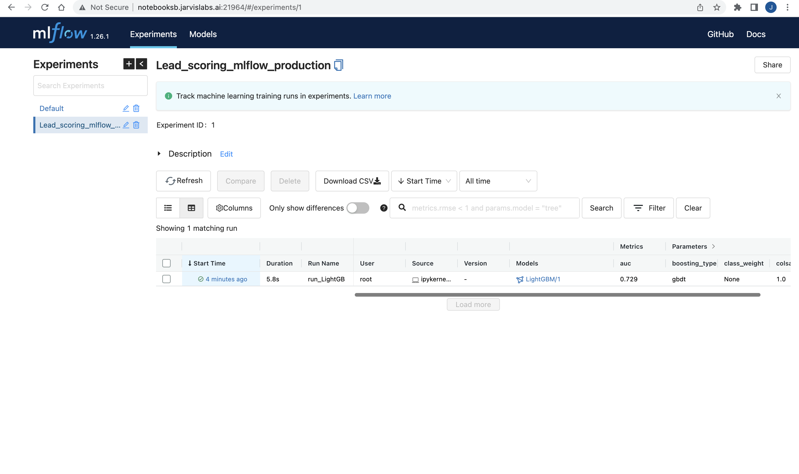

LightGBM with all artifacts

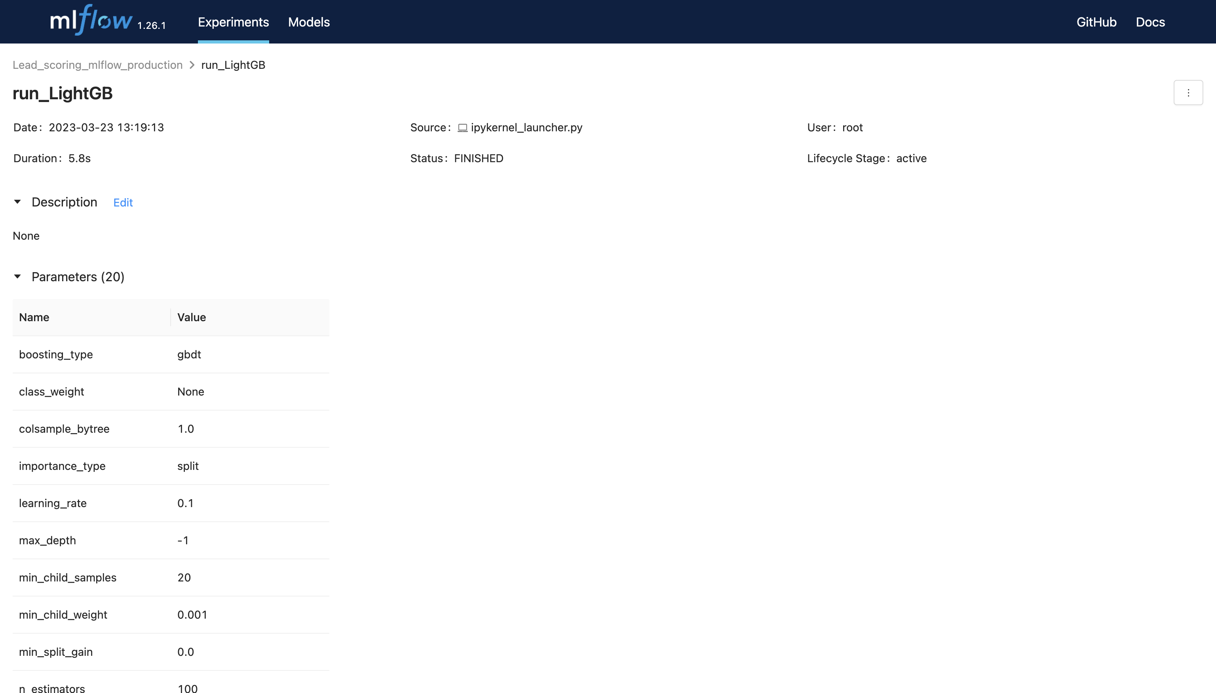

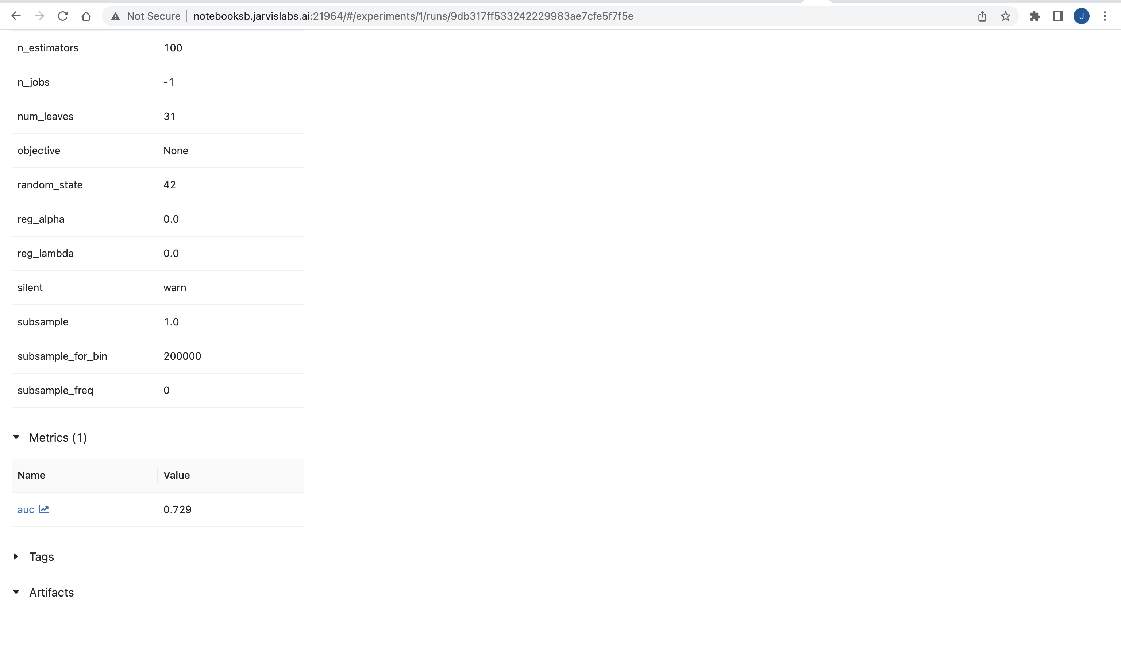

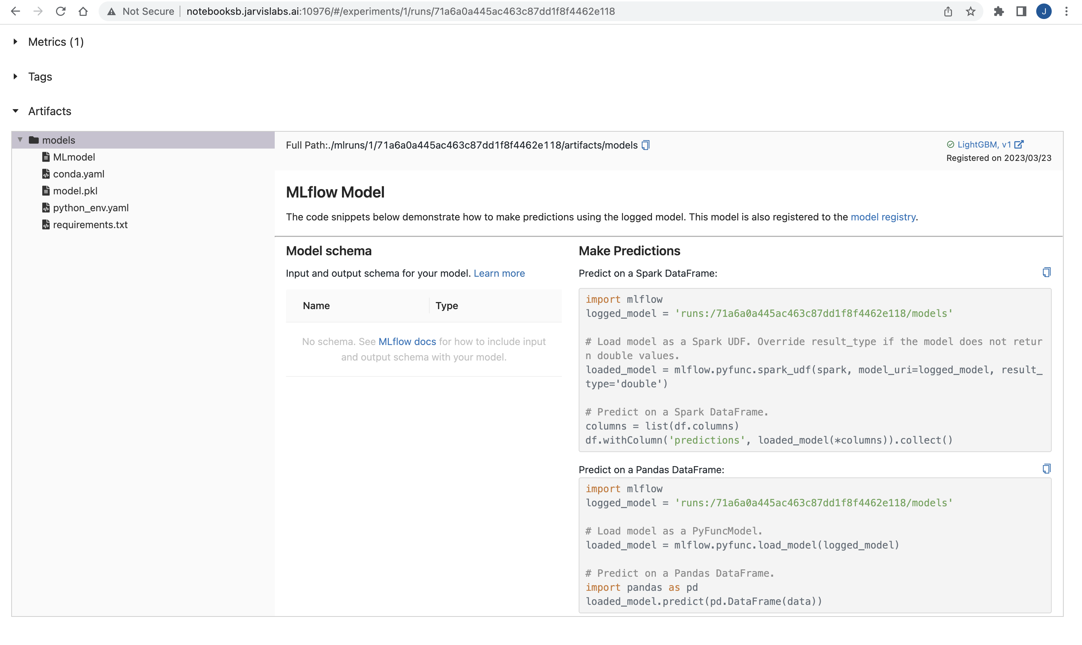

Model Registry with LightGBM in Production

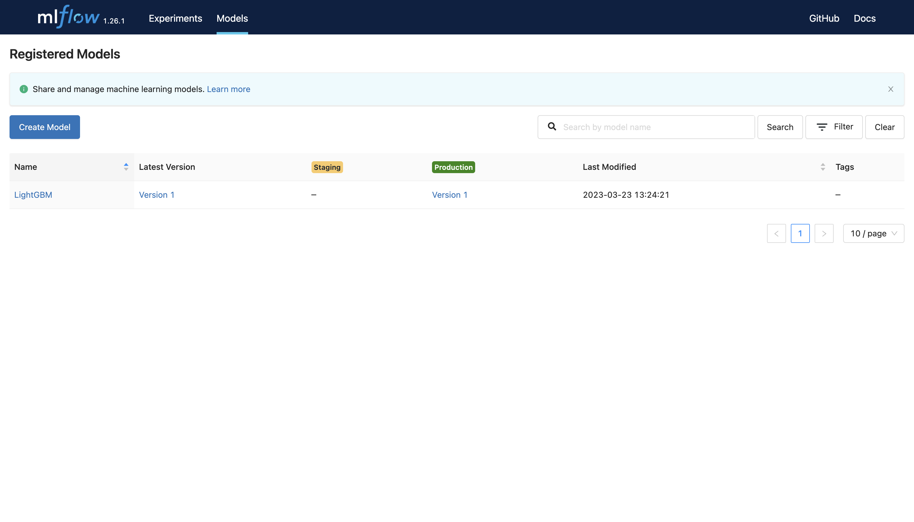

Airflow UI

Airflow DAG Graph (Lead_scoring_training_pipeline)

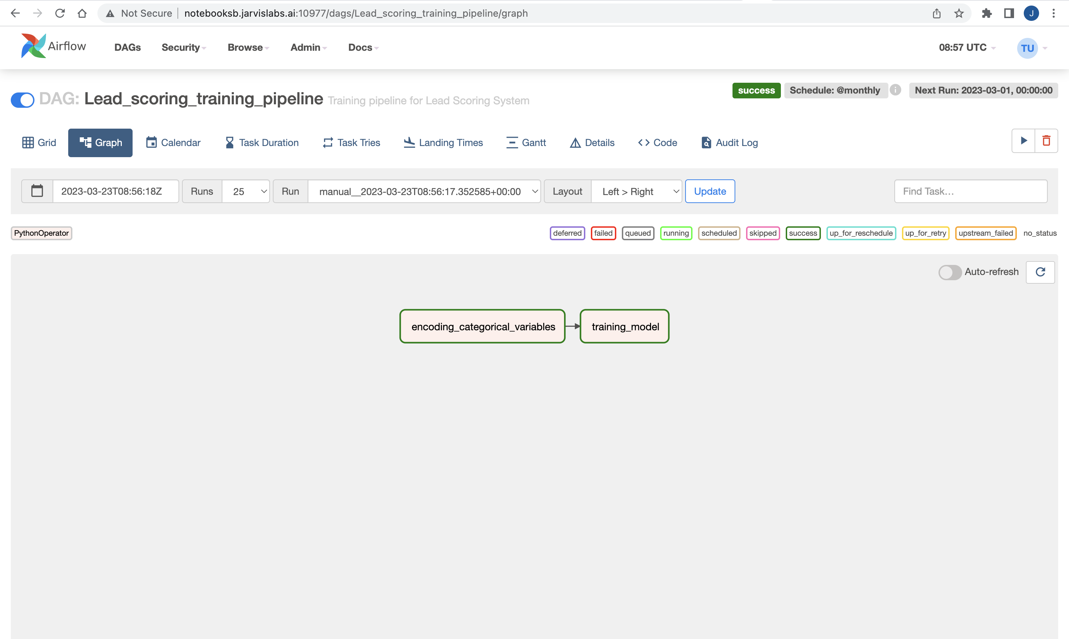

Airflow DAG Grid (Lead_scoring_training_pipeline)

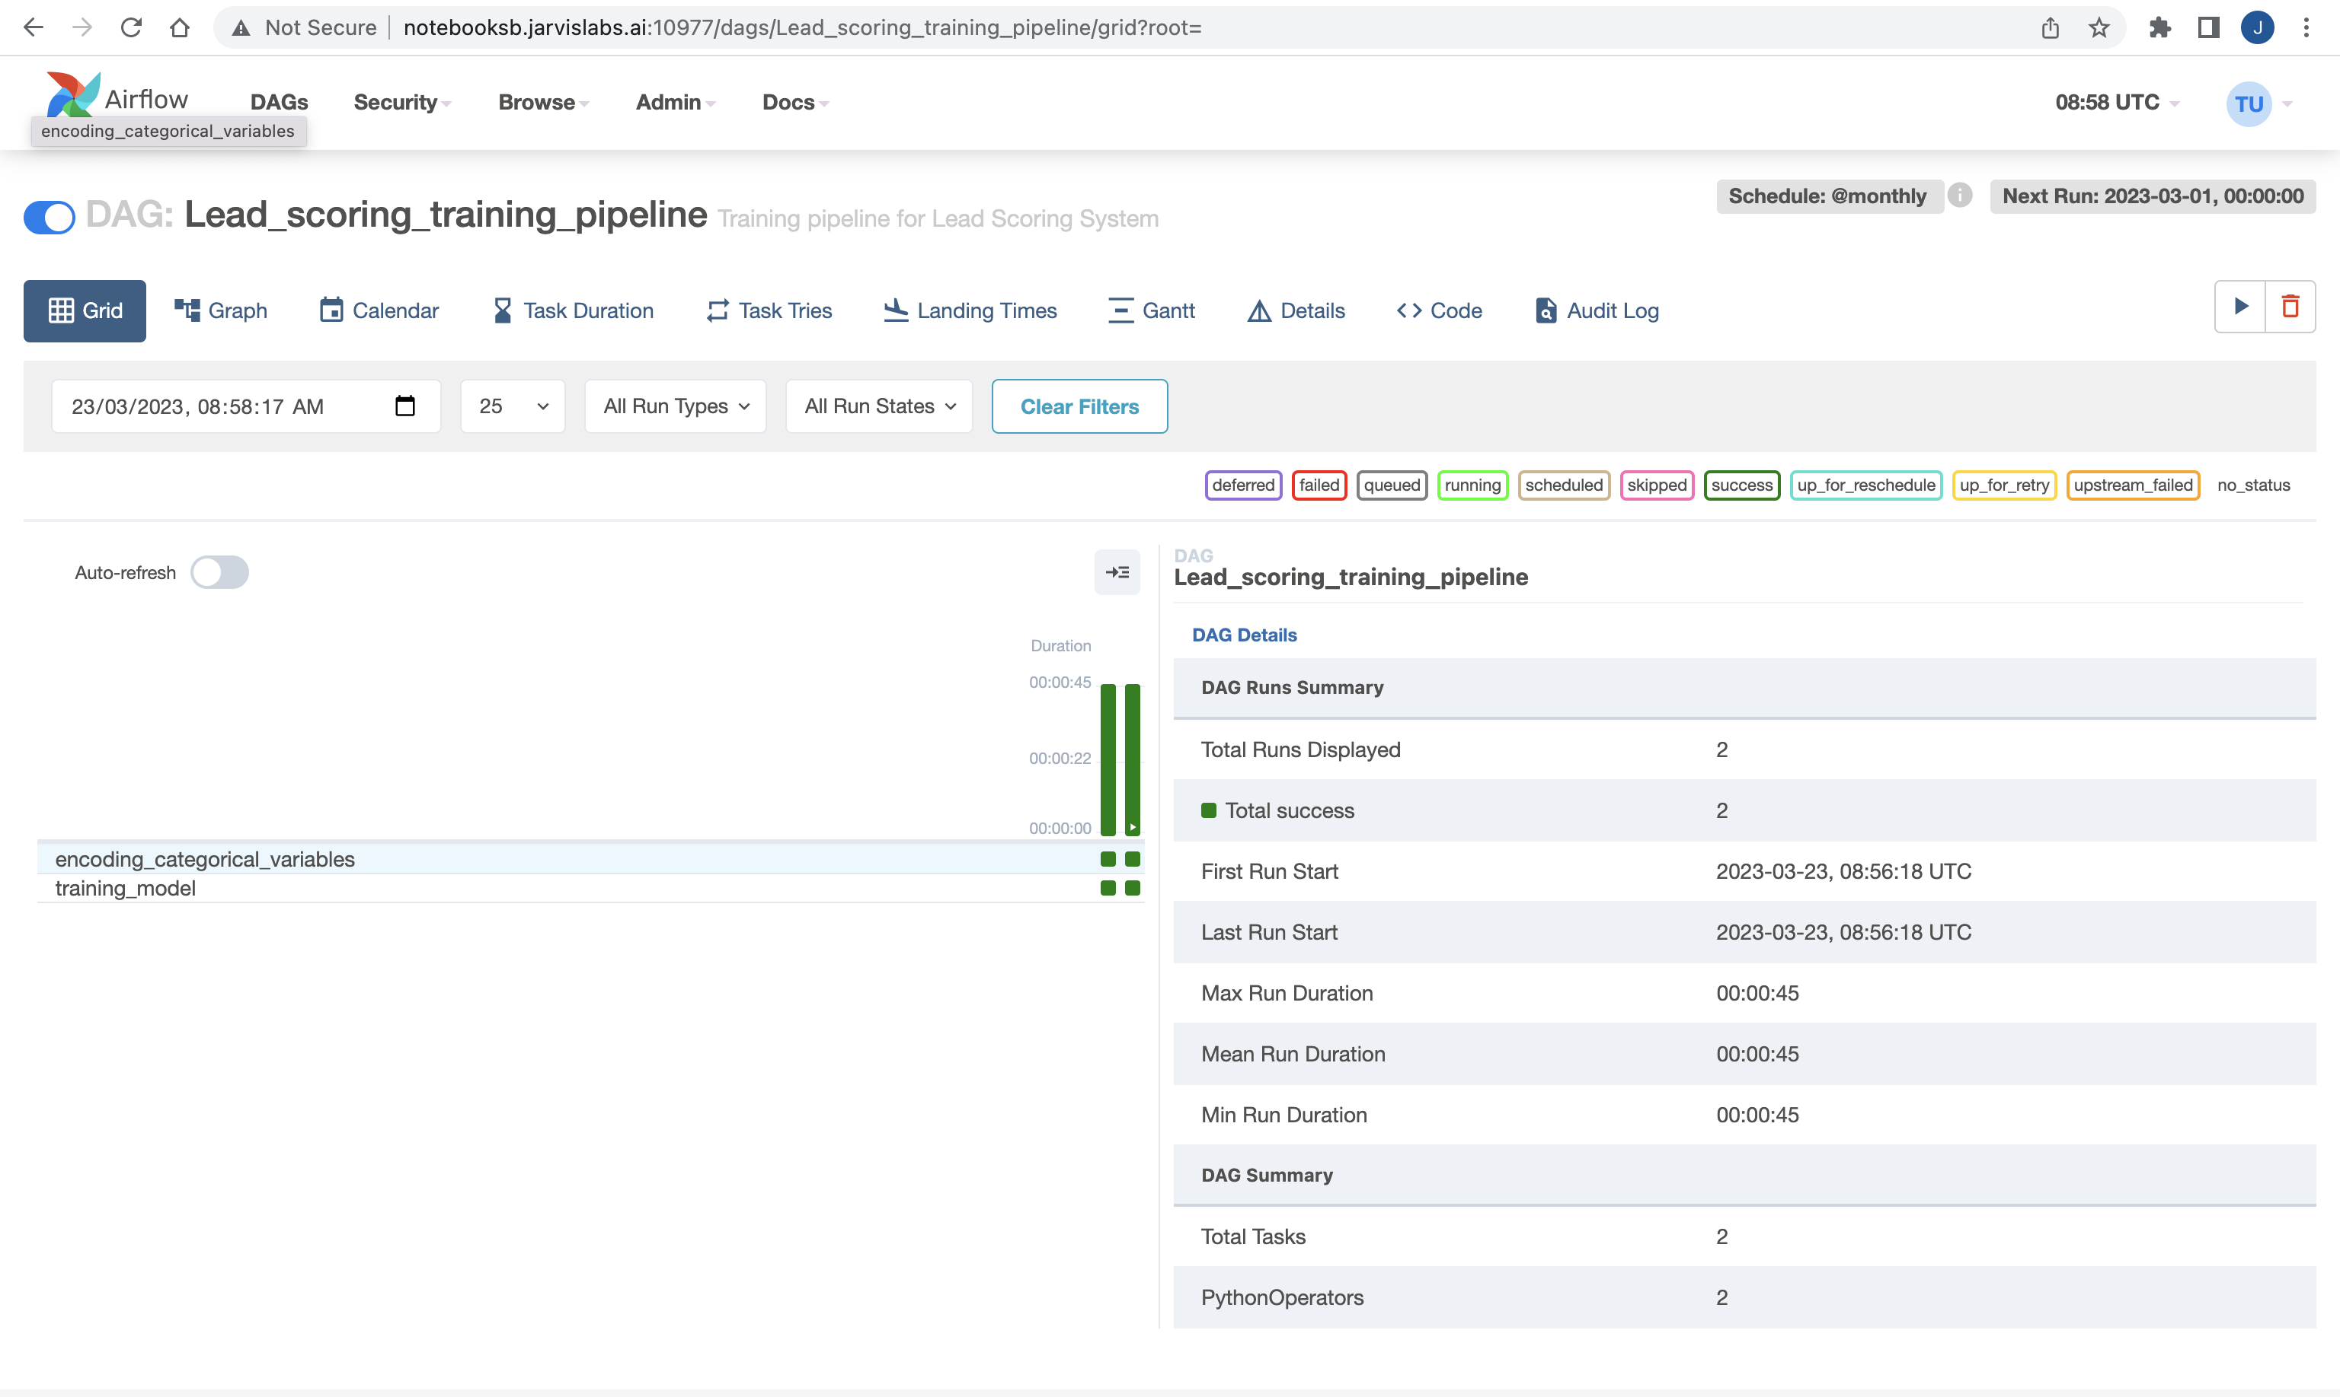

List of all Airflow DAGs

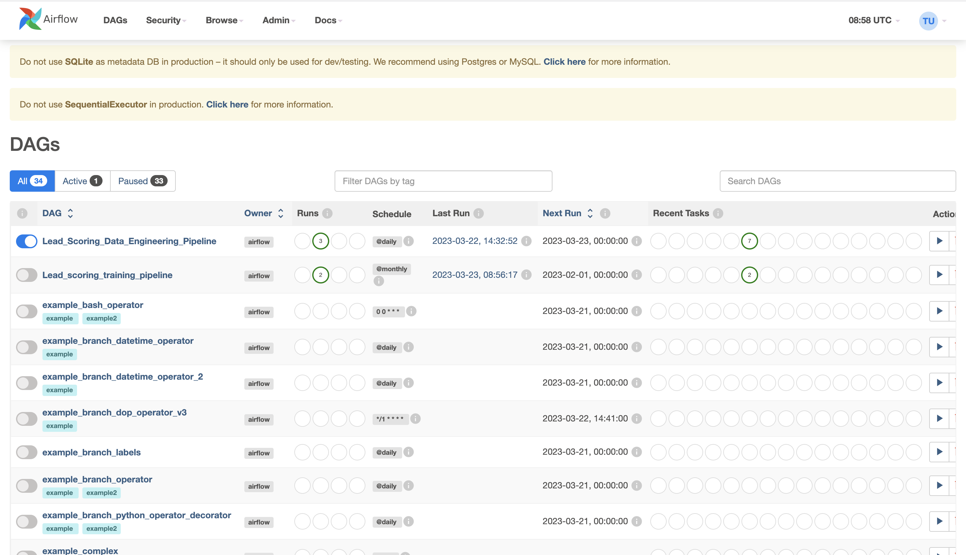

**Inference pipeline**

Airflow UI

Airflow DAG Graph (Lead_scoring_inference_pipeline)

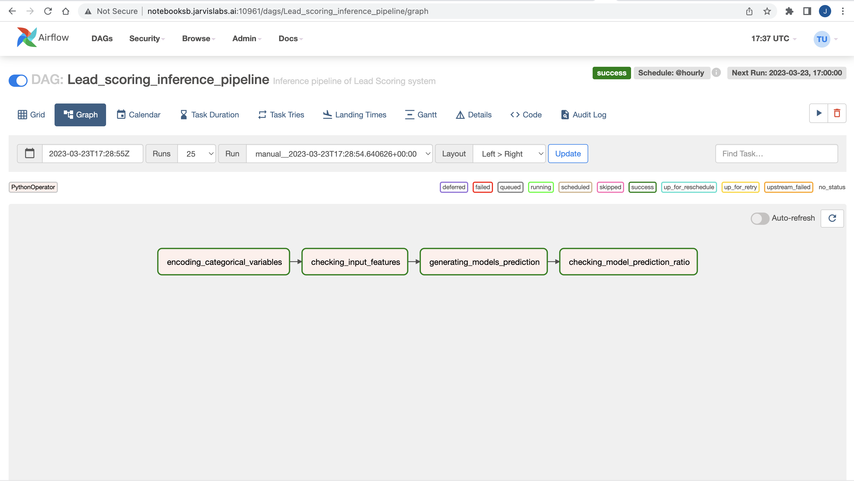

Airflow DAG Grid (Lead_scoring_inference_pipeline)

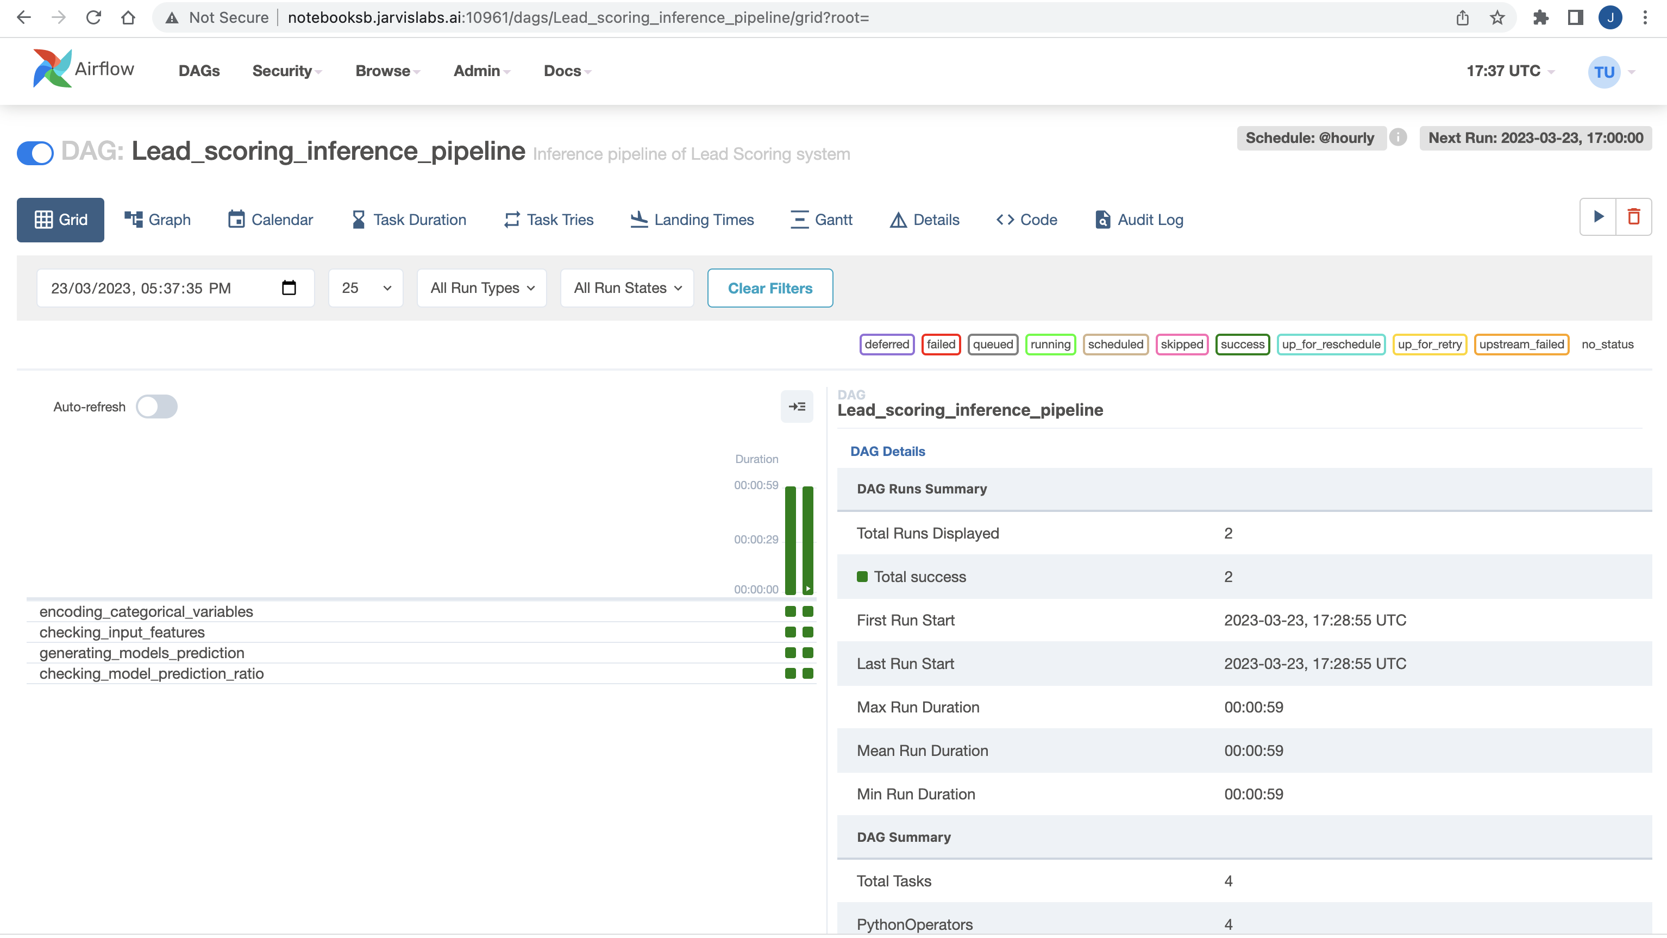

List of all Airflow DAGs

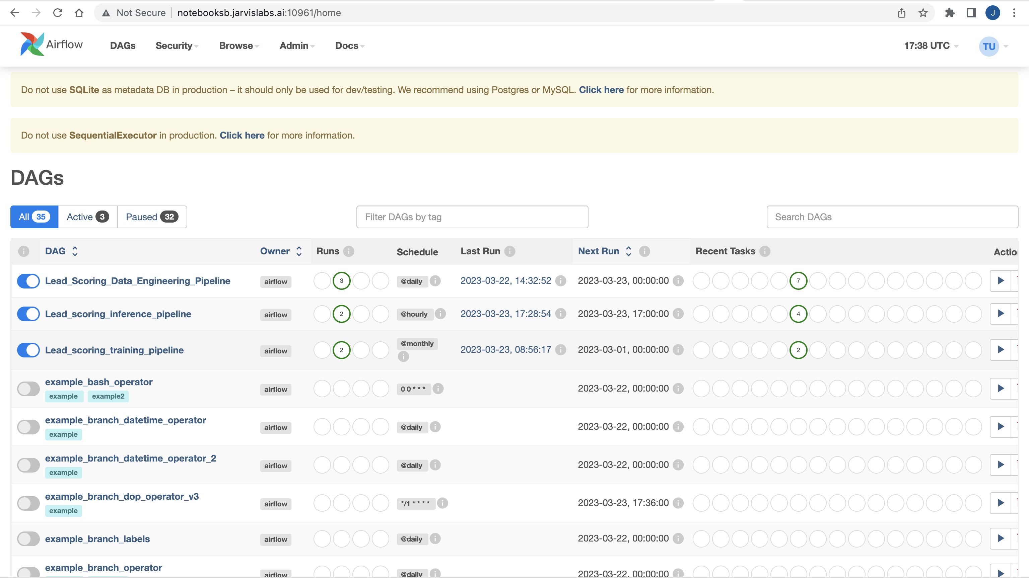

Running on Leadscoring_inference.csv

Airflow DAG Grid (Lead_scoring_Data_Engineering_Pipeline)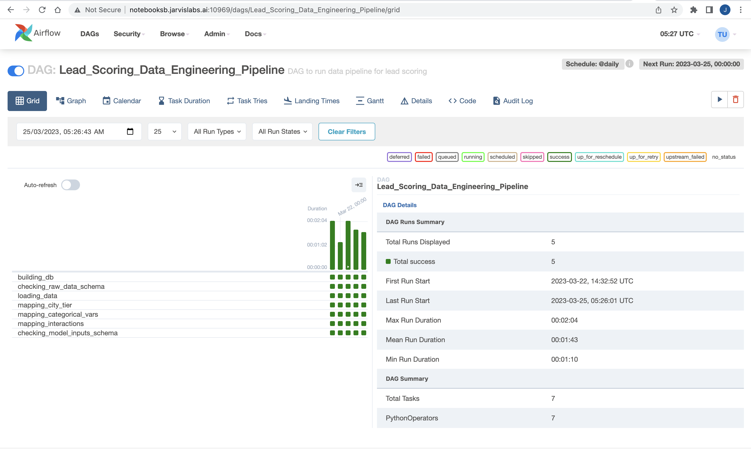

Airflow DAG Grid (Lead_scoring_inference_pipeline)

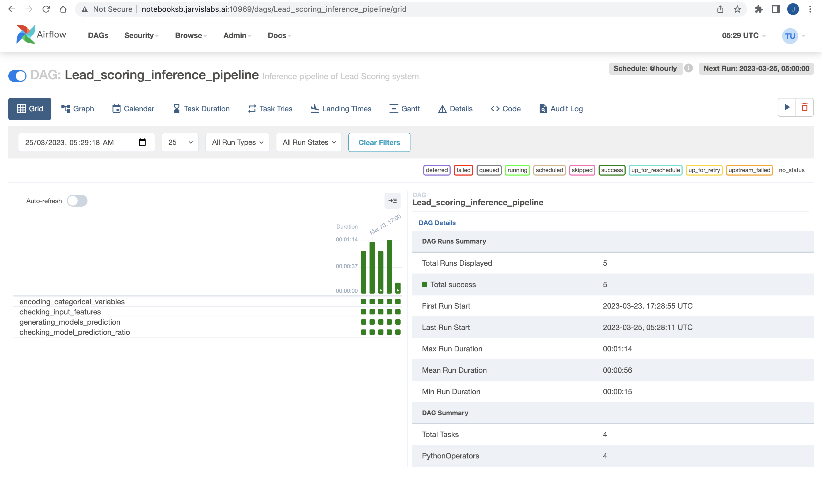

Output of prediction_distribution.txt after run on Leadscoring_inference.csv

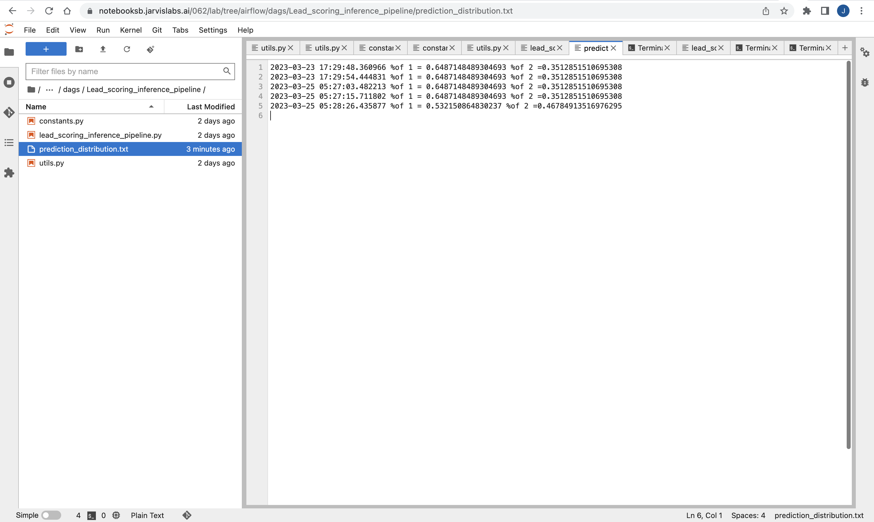

**Unit Test**

Four test successful run